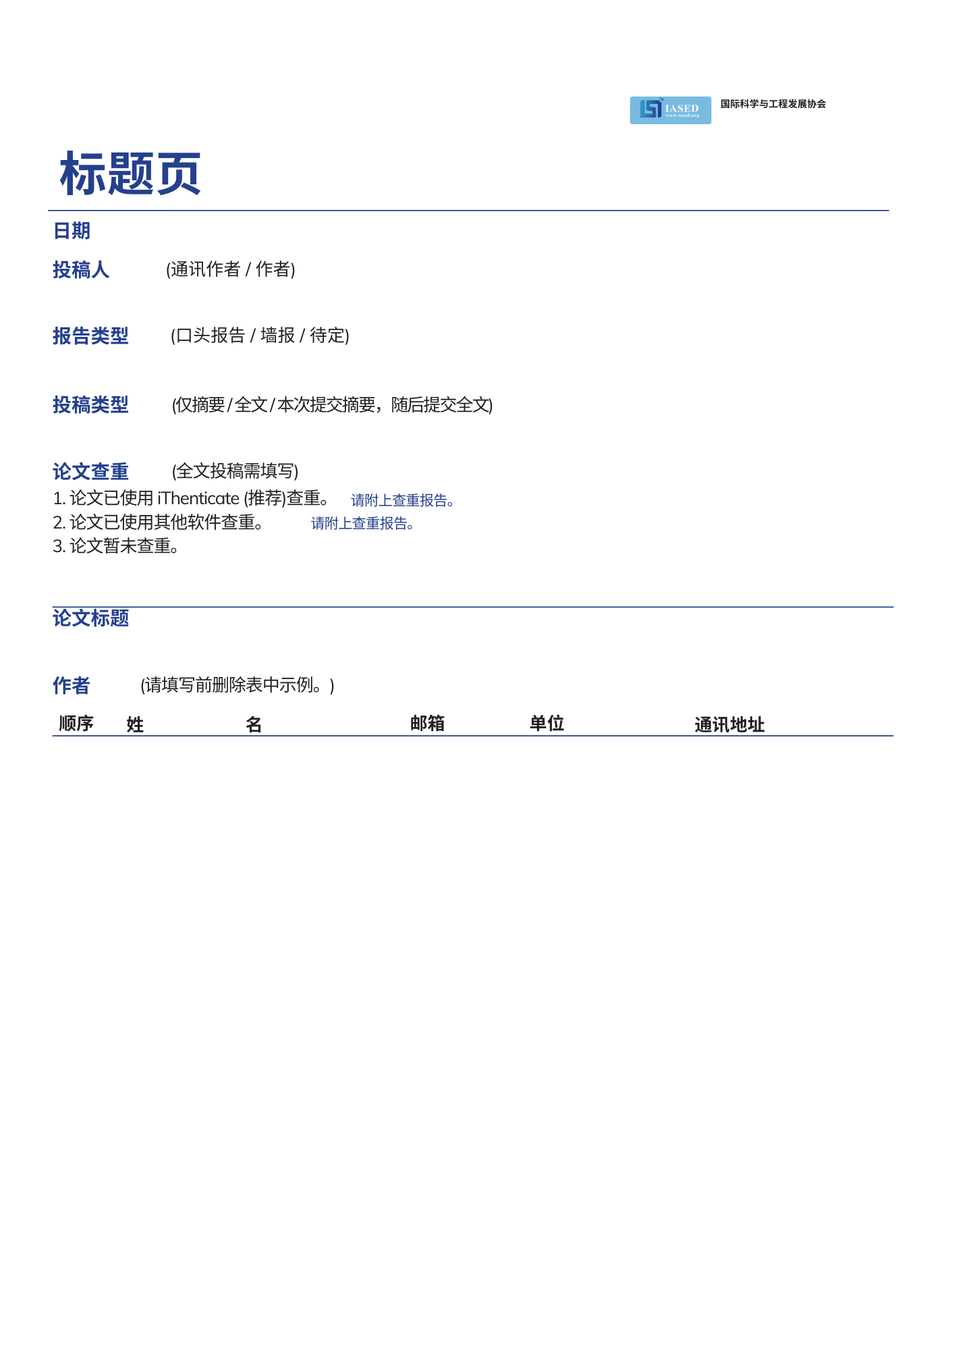

|  |  |  |  |  |  |
| --- | --- | --- | --- | --- | --- |
| 1 | 李 | 明 | 123@123.com | 某大学 |  |
| 2 |  |  |  |  |  |
| 3 |  |  |  |  |  |
| 4 |  |  |  |  |  |
| 5 |  |  |  |  |  |

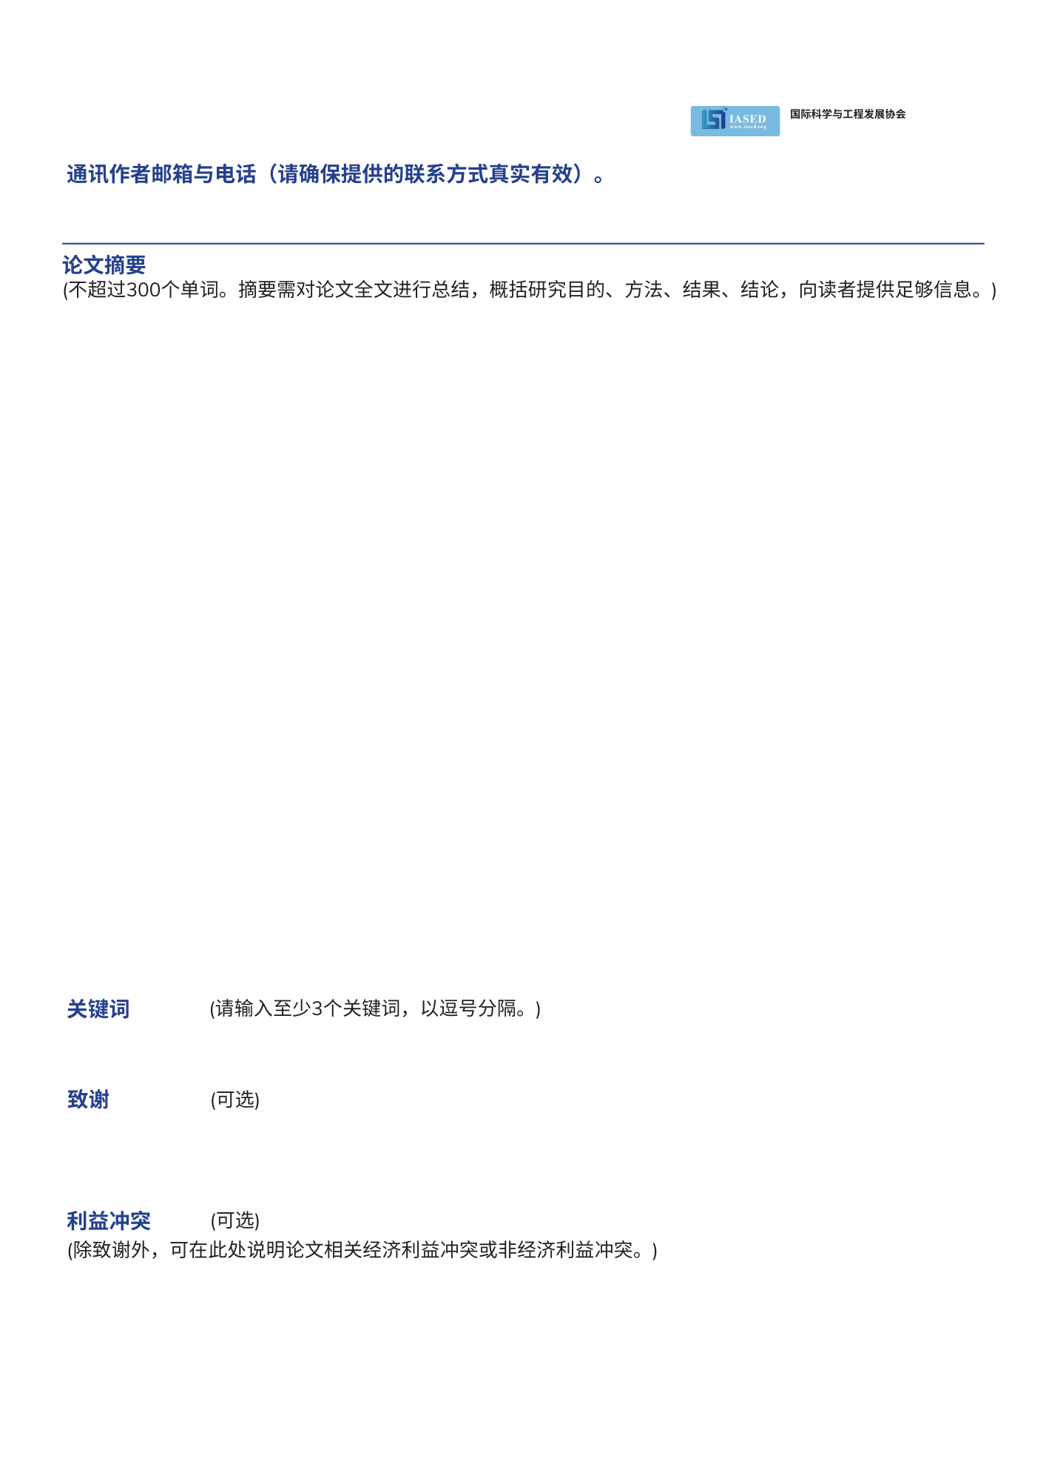

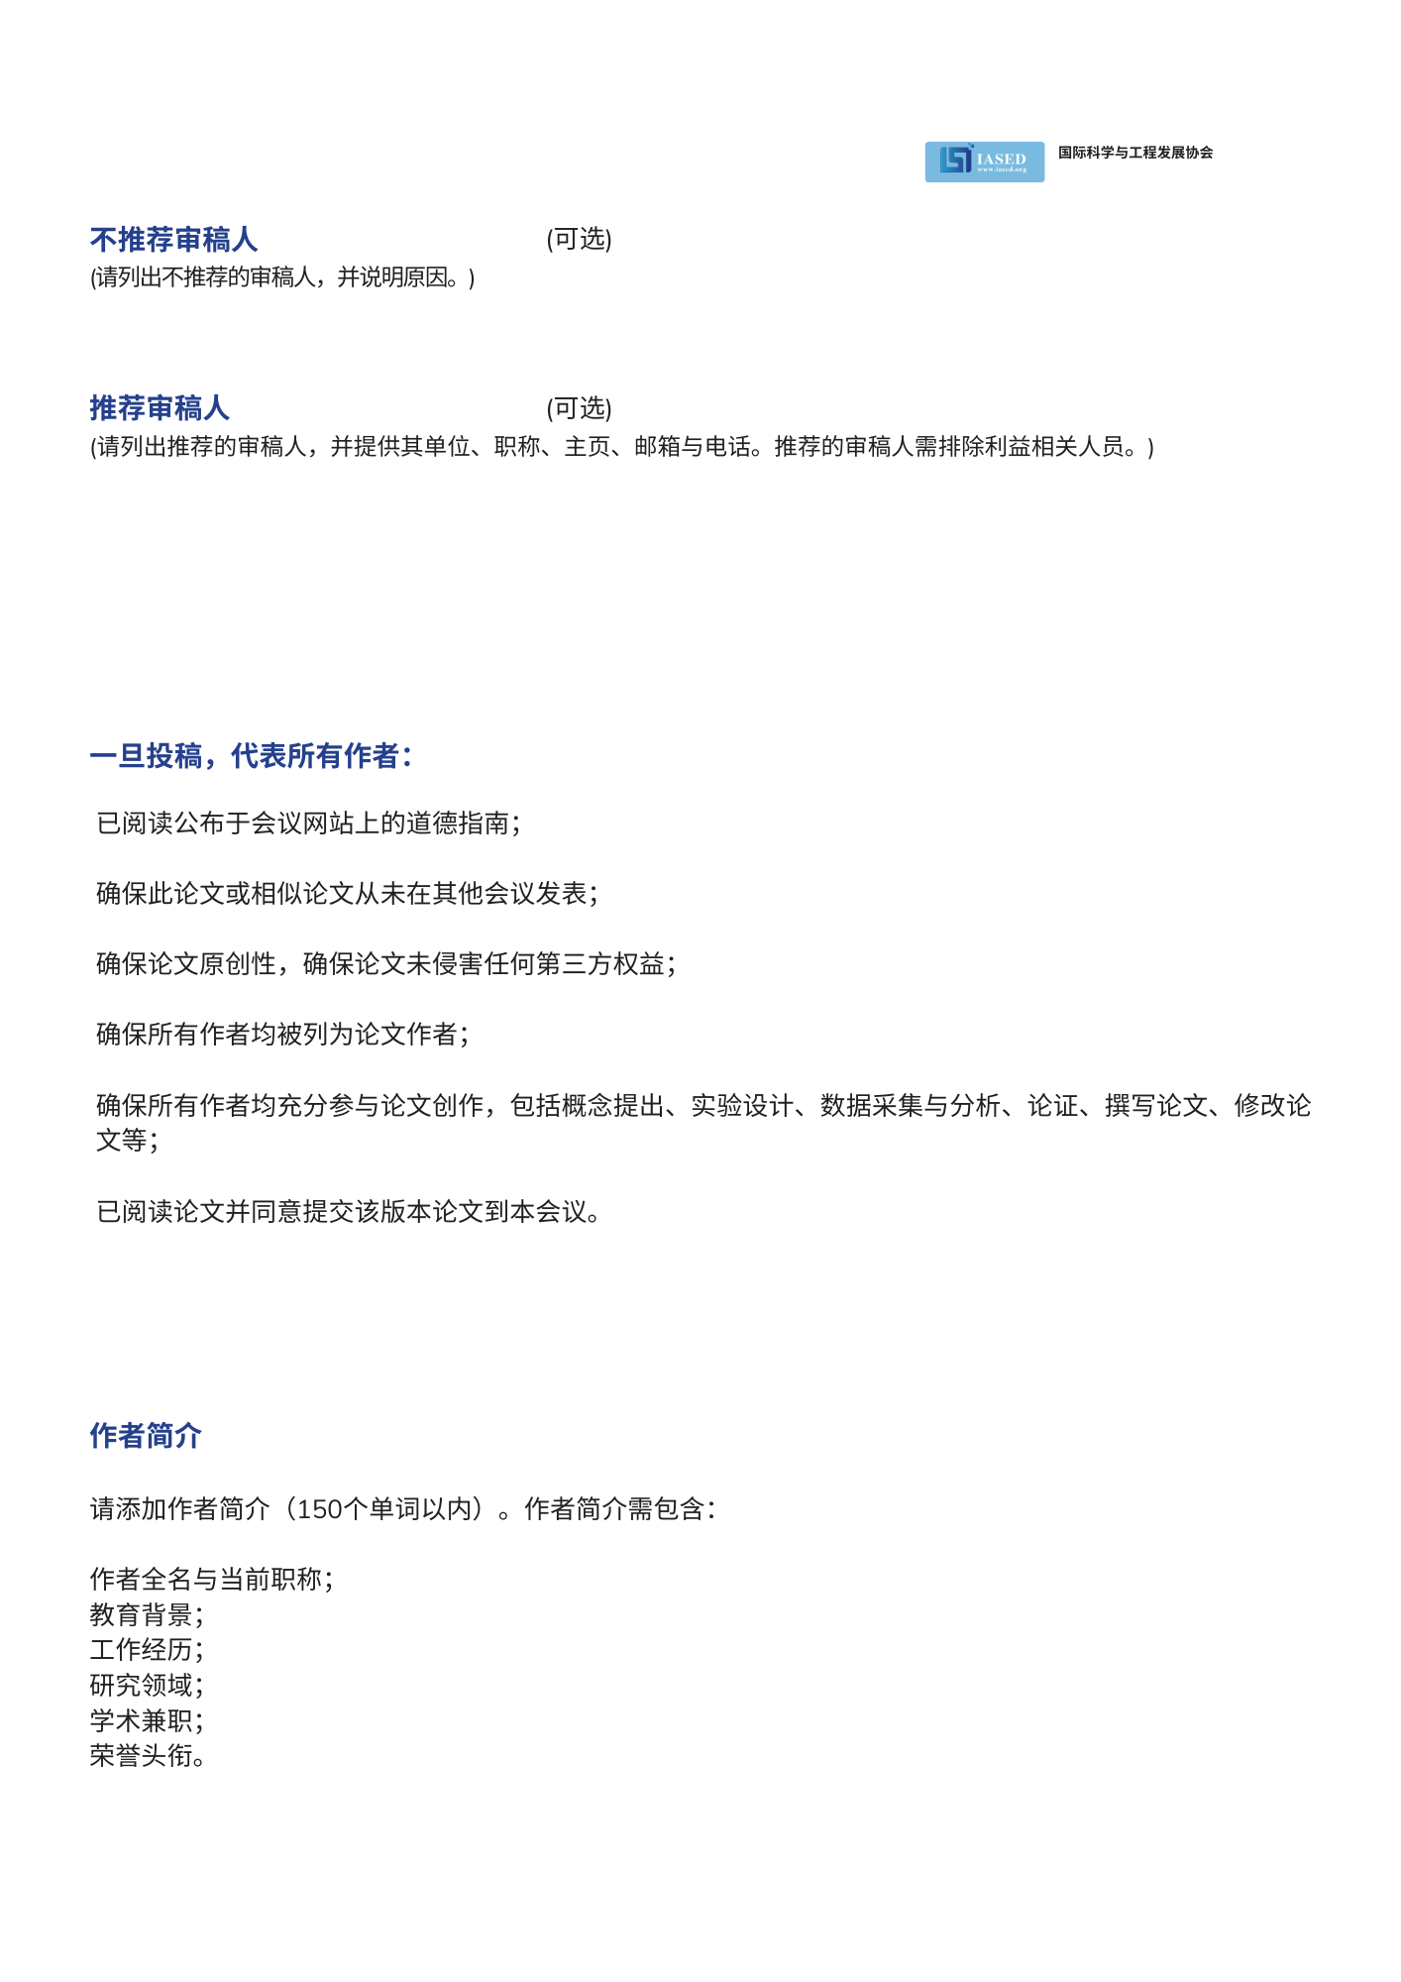



**会议秘书：Mia J. Lee**

**会议邮箱：ams@iased.org**

**会议电话：+852-30696823(English)**

**Monday-Friday, 9:00am-12:00pm and 1:30pm-6:00pm**

|  |  |
| --- | --- |
| **姓名** | **简介 （150个单词以内）** |
|  |  |
|  |  |
|  |  |
|  |  |
|  |  |
|  |  |